Chapter- 2
Need for Computational Experiments in Mathematics

To those who do not know mathematics it is difficult to get across a real feeling as to the beauty, the deepest beauty of nature. If you want to learn about nature, it is necessary to understand the language that she speaks in Richard Feynman , Nobel laureate in Physics in 1965
2.1 Introduction
Mathematics is the language and tool that enables us to understand and describe our world. Many students think that math is boring. How sad is that!? We need to allow our children to see that math is fascinating, beautiful, powerful and fun.
When we teach children music, we teach them the scales but we also play them pieces by accomplished artists to show them to the height to which they can aspire to grow. This is also the case with math. Arithmetic is important, but math is about so much more than this. Math encompasses all areas of life including music and art. Math is creative, mathematical thinking is an important and beautiful way to view the world, Math can show us the patterns in nature and how amazing our world really is. Math is so powerful; it gives us some control over our lives and our world, is used in everyday life and is also used in our careers and in technological advancement including computing, medicine and economics.
2.2 Why Maths is so boring
Many students find Math boring and difficult not only because of the abstract language in which it is written and taught but also due to fact that its failure to describe what they see around. Students also may not be feeling the need for it in daily life other than simple arithmetic. On the other hand, many gifted students underperform in school because they are not being challenged, and they especially need to be challenged and exposed to mathematical ideas that are more than just basic tools. More than how to add, subtract, multiply and divide. This fact is epitomized in the words of Mandelbrot, the father of fractal geometry - “Why is geometry often described as ‘cold’ or ‘dry’? One reason lies in its inability to describe the shape of a cloud, a mountain, a coastline, or a tree. Clouds are not spheres, mountains are not cones, coastlines are not circles, and bark is not smooth, nor does lightning travel in a straight line.”
Thus the familiar shapes that a child sees in nature have no place in high school curricula. Also we teach it in such an abstract way that the mathematics class is devoid of any fun.


Fgure 2.1 Shapes dealt in high school geometry

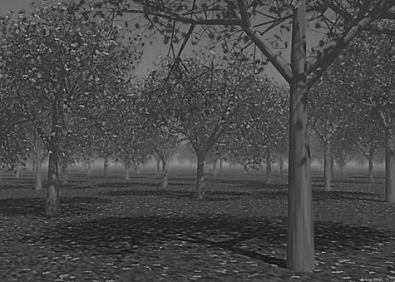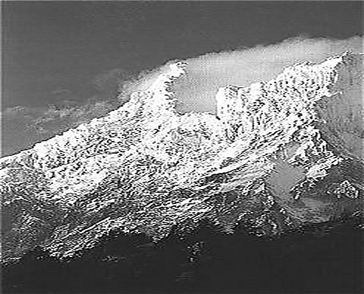

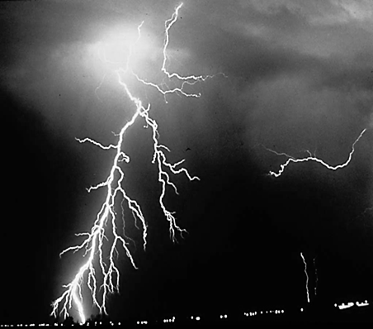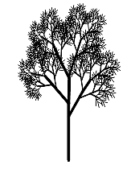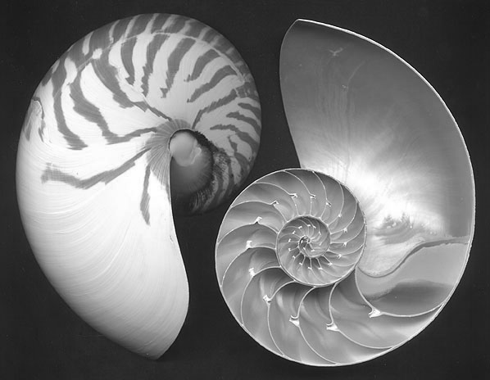

Figure 2.2 Shapes one sees in nature

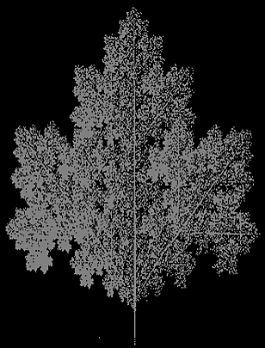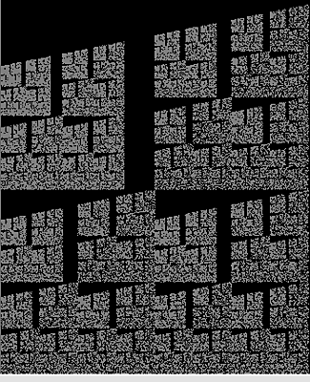
Figure 2.3 Shapes that can be generated using Math and drawn with the aid of computers
2.3 We need to make Math fun.
Although many students dread math class, or find it boring, it is important for teachers to do whatever they can to make math class fun. Students who enjoy math class perform better on standardized tests. It is therefore important for teachers to do all they can to help students have fun while learning math.
2.4 We need to show them what Math is about – that math is beautiful, powerful and useful, and why it is so important.
Mathematics began with ‘counting and measuring’ as useful procedures for dealing with physical reality. Later it evolved into the science of patterns and relationships. Mathematics relies on both logic and creativity. It is pursued both for a variety of practical purposes and for its intrinsic interest. For some people the essence of mathematics lies in its beauty and its intellectual challenge. For others, the chief value of mathematics is how it applies to their own work. Because mathematics plays such a central role in modern culture, some basic understanding of the nature of mathematics is requisite for scientific literacy. To achieve this, students need to perceive mathematics as part of the scientific endeavor, comprehend the nature of mathematical thinking, and become familiar with key mathematical ideas and skills.
2.5 We need to show how maths appear in nature
For example, it is quite amazing that the Fibonacci number patterns occur so frequently in nature
(flowers, shells, plants, leaves, to name a few) that this phenomenon appears to be one of the principal "laws of nature". Fibonacci sequences appear in biological settings, in two consecutive Fibonacci numbers, such as branching in trees, arrangement of leaves on a stem, the fruitlets of a pineapple, the flowering of artichoke, an uncurling fern and the arrangement of a pine cone. In addition, numerous claims of Fibonacci numbers or golden sections in nature are found in popular sources, e.g. relating to the breeding of rabbits, the spirals of shells, and the curve of waves. The Fibonacci numbers are also found in the family tree of honeybees. Plants do not know about this sequence - they just grow in the most efficient ways. Why do these arrangements occur? In the case of leaf arrangement, or phyllotaxis, some of the cases may be related to maximizing the space for each leaf, or the average amount of light falling on each one. Even a tiny advantage would come to dominate, over many generations. In the case of close-packed leaves in cabbages and succulents the correct arrangement may be crucial for availability of space.

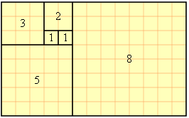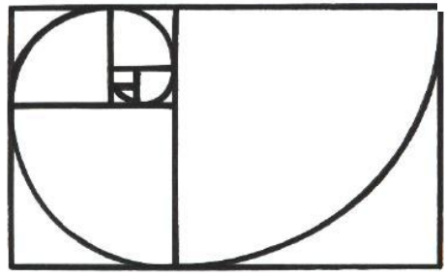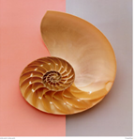
Figure2.4 patterns in nature- 1: Fibonacci Rectangles and Spirals
[ Foot Note: The sequence, in which each number is the sum of the two preceding numbers is known as the Fibonacci series: 1, 1, 2, 3, 5, 8, 13, 21, 34, 55, 89, 144, 233, 377, 610, 987, 1597, 2584, 4181 etc . This follows the recurrence relation F_{n} = F_{n-1}+F_{n-2} . The ratio of successive pairs is so-called golden ratio phi which is 1.618033989].

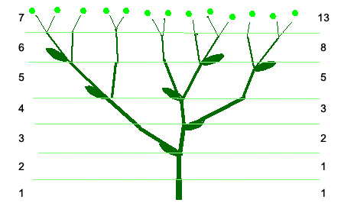

Figure2.5 Branching of trees

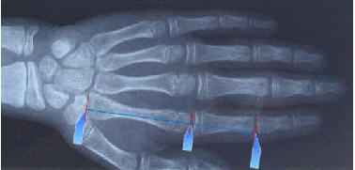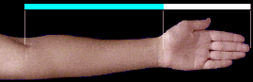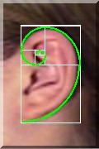
Figure 2.6 Golden Ratios and Phi-spirals in our body
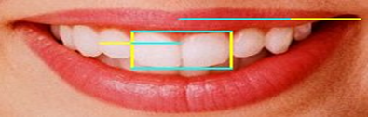
Figure 2.7 Phi proportions in teeth and lips

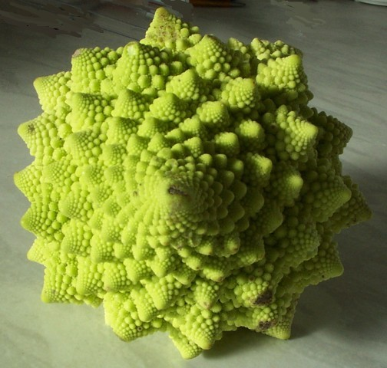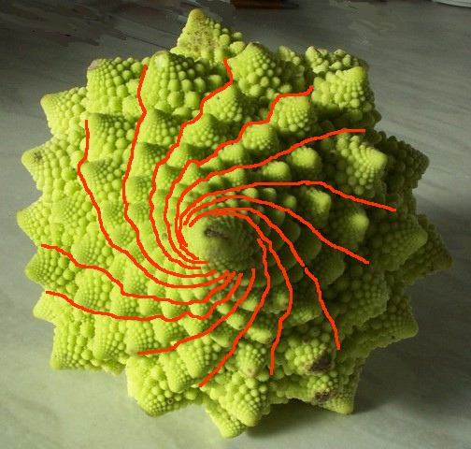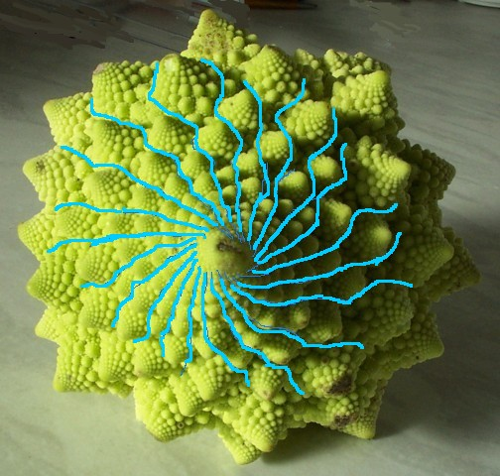
Figure2.8 Patterns in nature Romanesque Broccoli/Cauliflower. Each floret is peaked and is an identical but smaller version of the whole thing and this makes the spirals easy to see. Count the number of florets in the spirals on the cauliflower. The number in one direction and in the other will be Fibonacci numbers (13 and 21 in this figure)
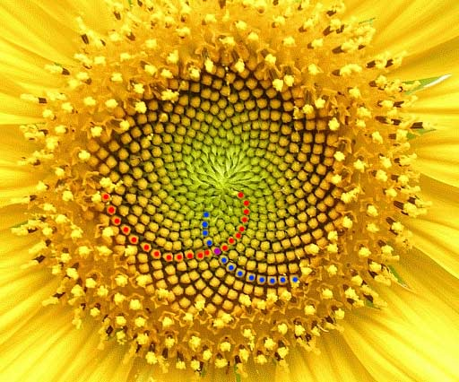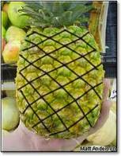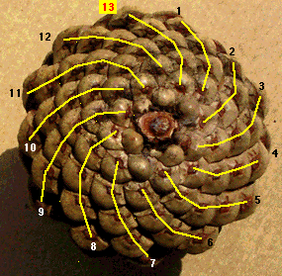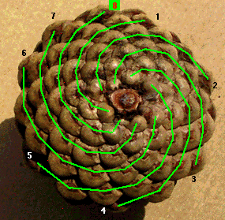
Figure 2.9 Figure patterns in nature . Number of left spirals and right spirals are two consecutive fibonacci numbers Sunflower, Pineapple , Pine Cones
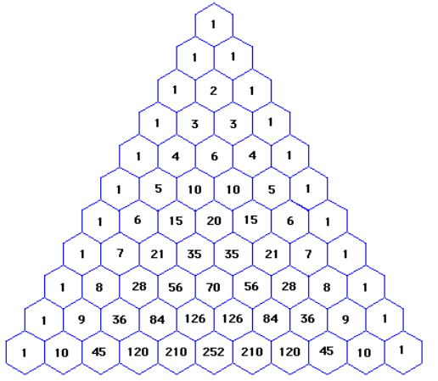
Figure 2.10 Patterns in Algebra : Pascal triangle. A number in a hexagonal cell is equal to sum of two numbers in the two hexagonal cells immediadiatly above the cell.
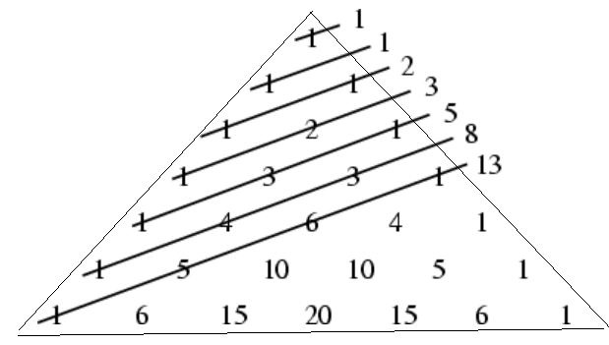
Figure 2.11 Patterns in Algebra : The "shallow diagonals" of Pascal's triangle sum to Fibonacci numbers

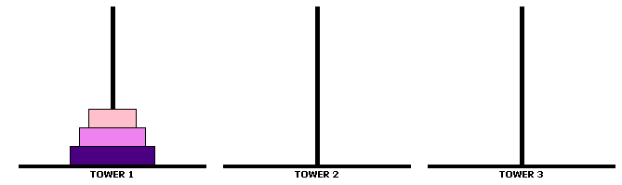

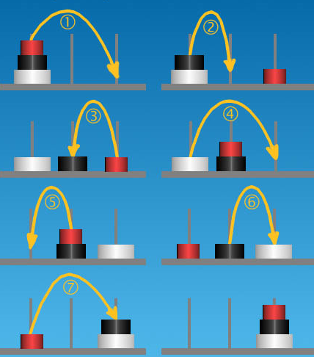

Figure 2.12 Patterns in Algebra : Number of steps required to move the discs follow the recurrence relation F_{n}= 2 F_{n-1} +1

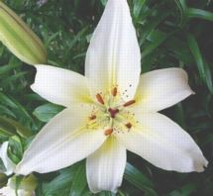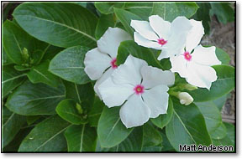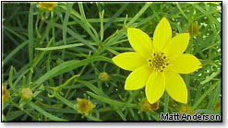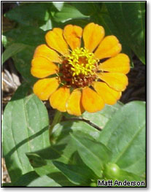
(2 sets of three petals, lilly) 5 petals flower 8 petals flower 13 petals flower
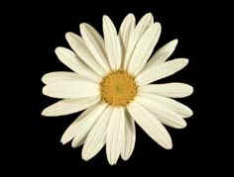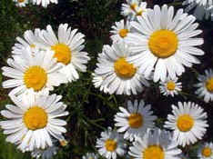
21 petals flower 34 petals flower
Figure 2.13 Mysterious patterns in nature : Number of Petals of flowers usually a fibonacci number

The Golden ratio occurs frequently in nature and it may be that humans are genetically programmed to recognize the ratio as being pleasing. Studies of top fashion models revealed that their faces have an abundance of the 1.618 ratio
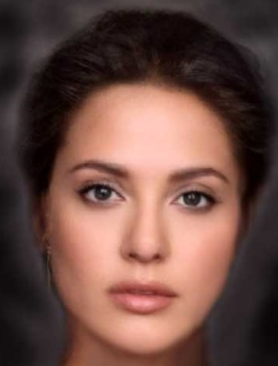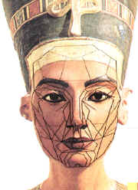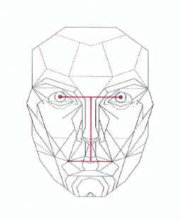
Figure 2.14 Faces with abundance of Golden ratio
2.6 We need to be enthusiastic about Math.
Enthusiasm is contagious. If students see their teacher is excited by Math, they are more likely to be excited about it themselves. If a teacher does not enjoy a subject, the students will not enjoy learning in that class either. The more positive energy a teacher has about a subject, the more enjoyable the class will be. A teacher who dislikes math may have a lower energy level than the teacher who enjoys math, and assign more seat-work. The more energy the teacher puts into planning and teaching, the more enjoyable the lessons will become, as students are getting out of their seats more.
We need to encourage students not be afraid of Math, to take risks when solving problems, that it is okay to make mistakes, that mathematicians often do! When a mistake is made in solving a mathematical problem we can often learn from this by asking questions such as “Why did we approach the problem that way?” “What would be a better way?”
When students can’t solve a problem straight away, they shouldn’t give up. Children are so used to instant gratification these days with all the technology they use in their everyday life, that they often believe that if they can’t answer a question within the first 30 seconds they should give up. This is often reinforced in math where mental problems are often expected to be answered quickly, that ‘fast’ solutions are rewarded in the classroom. We need to introduce them to problems they can’t do straight away and explain that even if they don’t end up solving the problem they have still learnt something, that they have ‘stretched their brain’ (brain plasticity), that they are learning to think mathematically, to think like a mathematician.
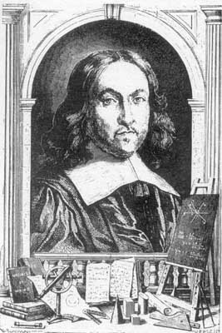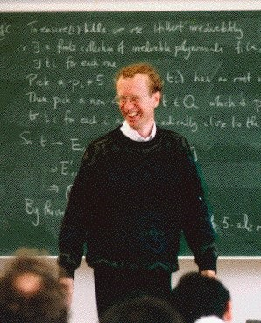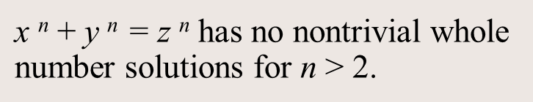
Figure 2.15 Fermat Anrew Wiles Fermat’s Last theorem
They should know that Andrew Wiles took 7 years to solve Fermat’s Last Theorem!
We need to make students understand that there are a lot of different areas of math and that some people are good at some areas and other people are good at others. Some people are really quick at arithmetic but find the visual spatial aspects of math difficult, and vice versa. We need to stress that just because someone is not fast at math doesn’t mean they’re not good at it, in fact a lot of math requires deep, slow analytical thinking.
Furthermore Math often requires creative thinking. It is not cut and dried. We need students to understand how important creativity is in this subject.
2.7 We should consider Multiple Intelligences that are at work
Every student will think in their own unique way. When teaching math don’t forget that students with different learning styles can bring their own particular skills to the subject of mathematics.
Visual/Spatial Intelligence: is mathematically important in engineering, architecture, geometry including higher level topics such as symmetry.
Verbal/Linguistic Intelligence: is mathematical literacy and being able to translate a problem from English into mathematical language.
Musical/Rhythmic Intelligence: rhythm, pattern recognition.
Logical/Mathematical Intelligence: inductive and deductive reasoning, logical thought.
Bodily/Kinesthetic Intelligence: is an intuitive understanding about movement and space, an important aspect of mathematical thinking.
Interpersonal intelligence: communication skills, group mathematical work, explaining concepts, discussing Math with other students.
Intrapersonal intelligence: conceptual understanding of the deeper questions that involve math, ability to question, to ask why?
Each of the intelligences belongs to everybody but we are particularly strong in at least one, and often more than one. Everyone gathers information differently – some of us prefer auditory means, some of us are visual learners, while others acquire information and learning by tactile or kinesthetic means. We also show our understanding through different media. In our culture, due to the impact of the IQ test, we have a bias towards the linguistic and mathematical logical intelligences and these are the subjects that are at the curriculums core and in which high achievement is rewarded. It is believed that all children can develop and strengthen each of the intelligences given appropriate opportunities within a rich environment and the encouragement to do so.
For students who display strong mathematical-logical intelligence we must ensure they are continually challenged in this area and are given opportunities to explore, experiment in order to exercise and strengthen this intelligence.
For students who operate out of other intelligences, opportunities to strengthen and exercise their mathematical logical intelligence are just as important. We have to assist children to be successful within a culture that places a high value on mathematical logical intelligence.
2.8 We need to use Computers to assist and explore new mathematics (Experimental mathematics)
Recent history of science suggests that leveraging human intuition with the combinatorial power of computers will lead to results far beyond what the unaided human mind is capable of. Learning mathematics is not an exception. One must turn the foundations of mathematics into an experimental science embracing computer technology as an essential teaching and research tool just as every other major branch of science has done.
Most mathematical work is done using pencil, paper and one’s mind, limiting the complexity that can be dealt with. Computers may be used to replace or supplement pencil and paper but they are rarely used as a research tool or to verify proofs.
Today’s children are lucky than our generations since they have so many opportunities than we had at school. Our possibilities of using computers were too limited. So, it is a great opportunity to have those entire technologies around if they are properly used in learning mathematics. What is better is technology supplies real entertaining stuff that can be very helpful in teaching. We know now that
• Technology can enhance mathematics learning.
• Technology supports effective mathematics teaching
• Technology influences what mathematics is taught
With computers, “technology has become a significant tool for promoting mathematical problem solving, reasoning, and exploration”
Computers help students develop algebraic thinking. They allow students to explore variables and relationships among variables. Furthermore, students are motivated to learn to generalize and formalize so that they can devise their own ways to command the computer to draw pictures or to solve numerical problems (Clements & Sarama, 1997). Besides, students can build on their own understanding by using computers as resource tools, or as communication tool to share their ideas with other learners. They can also share and compare their individual understanding and experiences.

On the other hand, communication tools like e-mail, listservs, bulletin boards, and chat groups allow teachers to exchange lesson plans and teaching strategies. In addition, computers increase the students’ motivation on subject and lessening anxiety among low ability students
2.9 Why the use of technology is important in mathematics and how do we use them?
First, and perhaps the most important, technological tools have the power to transform abstract mathematical concepts into concrete, visual representations. Especially in earlier grades, students may not be developmentally ready to work with abstractions. If they are provided tools that support their mathematical development, they can feel confident starting to learn advanced level concepts.
Second, technology allows students to actively participate in mathematical problem solving. Spreadsheets, graphing calculators, and dynamic geometry software provides the students with an opportunity to manipulate mathematical situations in order to observe patterns, relationships, and generalizations.

Technological tools also motivate students. When students allow becoming active in learning, they can develop their own strategies and understandings. With the help of technology, students can discover mathematical relationships and connections.
Technology enriches the range and quality of investigations by providing a means of viewing mathematical ideas from multiple perspectives
Finally, technological tools help prepare students to be future problem solvers and technology users. Mathematics in the real words is done with technology. In today’s world, not introducing students on the use of technology is doing them disservice”
In School Mathematics more attention must be given to
(1) developing and understanding of variables, expressions, and equations;
(2) using a variety of methods to solve equations and informally investigate inequalities.
In Algebra classes, students often have problems with understanding of variables, and equations. At this point, spreadsheets allow them to include variables in formulas, and thus to test relationships in a way that are not possible to do with paper-and-pencil work. The most benefits of this are the fact that in spreadsheets, variables do not have names. Cells play the role of variables. The cell itself corresponds to the variable whereas the contents of the cell correspond to the current value of variable.
To understand the difference better, we can consider problem of helping students solve for x, unknown, in the equation 6x + 2 = 3x – 4. By tradition, we focus on solving this algorithmically. First, we try to have students understand the concept, and then give them a set of rules to find solution; I believe that makes their thinking limited. However, computer spreadsheet’s graphing capabilities help them see equations and their solutions in new ways.

With spreadsheets, students can also look for patterns, and investigate sequences and series.
In algebra classes, students are being asked to show their work and justify their simplifications, often without formal proof process. The exploratory and visual natures of graphing calculators or spresdsheet allow students to investigate algebraic properties, to test, and refine conjectures; and to find counterexamples.
2.10 Why we need to introduce fractals in schools?.
Current geometry which we are teaching in schools and colleges is called Euclidean geometry, the axiomatic study of lines, circles, and triangles. From this perspective, nature is like noisy mathematics—rough and crumpled, slightly out of focus.

Euclidian geometry cannot describe familiar objects like leafs, trees, clouds and mountains found in nature. Students easily get bored of this geometry because they are not able to relate with reality.

Fractals Geometry is an alternative to Euclidean geometry. The elements of this geometry are not lines and circles but iterations and self-similarities. The surfaces of geometrical objects in this geometry are not smooth. They are jagged; their features are not perfect but broken. Fractals reveal an entirely new geometry that enables us to understand formerly inexplicable real-world phenomena.

Fractals provide insight into the distribution of galaxies - The distribution of stars in the space is fractal in nature. If this nature is true for all scales, it may force us to abandon big-bang theory.
They are also used to study the spread of bacterial colonies, the grammar of DNA, the shape of coastlines, changes in climate, development of hurricanes, growth of crystals, percolation of ground pollutants, turbulence of fluids, and the path of lightning.
They have been employed to create powerful antennas, to develop fiber optics, to monitor financial data, to compress images, and to produce artificial landscapes. Their influence has been felt in art, architecture, drama (Arcadia), film (Jurassic Park), music, and poetry.
Thus main features of fractal objects are
Detail at every scale
Possesses self-similiarity to certain degree
Produced by iterative process
To characterize these objects mthematicians introduced the concept of fractal dimension. That is , dimension of an object need not be an integer, it can be a fraction.
The study of this mathematics needs experimentation, preferably with computers since objects in this geometry can only be produced by iteration.
Much of mathematics we are doing in school and colleges are theoretical. It was not so in the eighteenth and nineteenth centuries. Mathematics was both experimental and theoretical. But during twentieth century the theoretical aspect somehow dominated. We need to do a balancing act now. Fractals represent a rebirth of experimental mathematics, enabled by computers and enhanced by powerful evidence of utility.
World over attempts are being made to introduce fractal geometry in schools. Fractals enable everyone to enjoy mathematics. Nothing else can make such a striking—and important—claim.

They focus on teaching fractals, not primarily because fractals are important but because learning about fractals is, as one student put it, “indescribably exciting . . . and uniquely intriguing.”

It is easy to see why (According to Lynn A . Steen, A mathematician pioneering to spread Fractal education):

1) The first steps are so much fun. Exploring fractals creates unprecedented enthusiasm for discovery learning among both teachers and students
2) Fractals are beautiful. Stunning visuals appeal to the mind’s eye and create contagious demand for continued exploration.
3) Anyone can play. Exploration of fractal geometry appeals to students of every age, from primary school through college and beyond.
4) Fractals promote curiosity. Simple rules, easily modified, create nearly uncontrollable temptations to explore different options to see what surprising patterns will emerge.
5) Simple ideas lead to unexpected complexity. Fractals are more life-like than objects studied in other parts of mathematics; thus they appeal to many students who find traditional mathematics cold and austere.
6) Many easy problems remain unsolved. Fractals are rich in open conjectures that lead to deep mathematics. Moreover, the distance from elementary steps to unsolved problems is very short.
7) Careful inspection yields immediate rewards. Insight and conjectures arise readily when our well-developed visual intuition is applied to fractal images. In studying fractals, children can see and conjecture as well as adults.
8) Computers enhance learning. The visual impact of computer graphics makes fractal images unforgettable, while the unforgiving logical demands of computer programs yield important lessons in the value of rigorous thinking.
Current problems in introducing Fractals in schools and colleges
1. Teachers are not trained in fractal mathematics and also they are not trained to use computers for teaching mathematics
2. Unavailability of free softwares that allow students to explore fractal mathematics without doing any programming.
2.11 Our contribution:
We have found out ways to do and draw fractals in Spreadsheet with out doing any programming. A one week exposure to a spreadsheet package is enough to master the tricks required for doing fractal mathematics in a spreadsheet like excel.
Fractals in come in different families. IFS (Iterated Function System) Fractals, Newton Fractals, Mandlebrot and Julia Fractals, L-System Fractals, Apollonius circle fractals (Also called Indra’s Pearls) etc. All these fractals can be drawn in spreadsheet. In addition, students can easily modify the fractals to produce new kinds of fractals with ease.
Once they master doing fractals in Spreadsheet, it will be quite easy for them to use the same concept for experimenting with conventional mathematical subject like Calculus.
Infact University of California Berkely [9] has pioneered in this by introducing the book “ Calculus without tears” for 5th grade students. This is fully experimental in nature.

2.12 Summary
As people living in the 21st century, we must be aware of the importance of the technology in our children’s life by giving them every possibility to make them critical thinkers, and good decision makers. We, as teachers, must have much responsibility to imply technology in our teaching that needs professional education. By doing this, we should realize that how can technology be used and applied into the curriculum? What changes are necessary to make? How are students interacting with the tool? Besides, we should always remember that technology could only be a way to support our teaching, to help our students understand mathematical concepts deeply.

2.13 References
[1] Golden ratio http://www.world-mysteries.com/
[2] Susan Turnbull, Creating a Maths Enrichment program in a Primary School, http://www.mansw.nsw.edu.au/pd/conference/2008/presentations/Turnbull-Maths-Enrichment-Program.doc
[3] Swan, Paul. Maths facts, fun, tricks and trivia R.I.C. Publications 2007, WA
[4] Niederman, Derrick. Mind-Stretching Maths Puzzles, Sterling Publishing 3005, New York
[5] Cheng-Yao Lin, Beliefs about Using Technology in the Mathematics Classroom: Interviews with Pre-service Elementary Teachers, www.ejmste.com/v4n2/Eurasia_v4n2_Lin.pdf
[6] Julie Clark, Carol Aldous and Jim Davies, Science, Technology and Mathematics Teaching and learning in Rural South Australia : Problema and Prospescts , www.aare.edu.au/06pap/bar06568.pdf
[7] Brown, S., Galloway, C., & Orrill, C. (2002). Lead you students in mathematical discovery. Learning and Leading with Technology, 29 (5), 22-27.
[8] Clements, D. H., & Sarama, J. M. (1997). Computers support algebraic thinking. Teaching Children Mathematics, v.3, p.320-325.
[9] Calculus Without Tears - A New Approach to Calculus ; http://www.berkeleyscience.com/
2.14 Websites
Nrich Maths Website, www.nrich.maths.org , Cambridge University
Cool Maths Website, www.coolmaths.com.au
Plus online magazine, www.plus.maths.org
Fractals, http://www.fractalfoundation.org includes fractal videos.
Fibonacci Numbers and Nature http://www.maths.surrey.ac.uk/hosted-sites/ R.Knott/Fibonacci/fibnat.html`

